Project Design Phase-II Customer/User Journey Map

|  |  |
| --- | --- |
| Date | 28 October 2022 |
| Team ID | PNT2022TMID38117 |
| Project Name | Retail Store Stock Inventory Analytics |
| Maximum Marks |  |

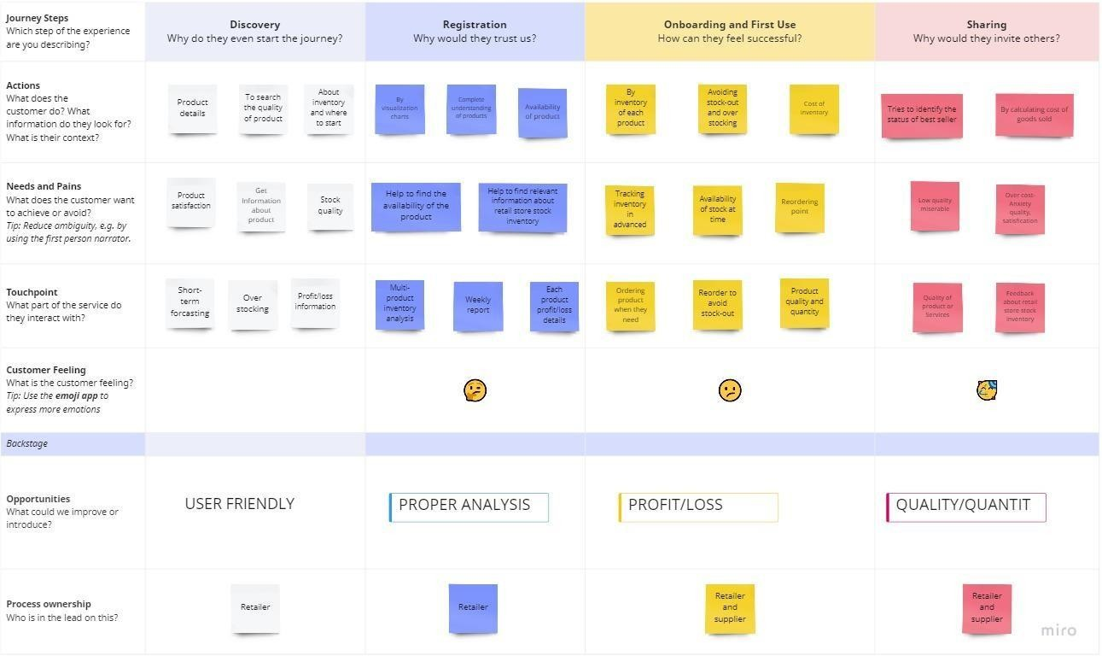Customer Journey Map: